**Worksheet 1**

**Student Name:** Sakshi Kumari  **UID:** 21MCA2585

**Branch:** MCA  **Section/Group:** 3A

**Semester:** 2nd **Date of Performance:** 17/02/2022

**Subject Name:** Advance Internet Programming lab

**Subject Code:** 21CAP655

1. **Aim/Overview of the practical:**
2. **Task to be done:**
3. Write a program to find the duplicate numbers on the Integer array in Java?
4. Write a program to find the largest and smallest numbers in an unsorted array?
5. **Concept used:**
6. **Steps/Commands involved to perform practical:**
7. **public** **class** Wrk1 {

**public** **static** **void** main(String[] args) {

// **TODO** Auto-generated method stub

**int** [] arr = **new** **int** [] {4, 2, 7, 4, 2, 7, 8, 8, 3};

System.***out***.println("Duplicate elements in given array: ");

//Searches for duplicate element

**for**(**int** i = 0; i < arr.length; i++) {

**for**(**int** j = i + 1; j < arr.length; j++) {

**if**(arr[i] == arr[j])

System.***out***.println(arr[j]);

}

}

}

1. **public** **class** Wrk2 {

**public** **static** **void** main(String[] args) {

// **TODO** Auto-generated method stub

**int** numbers[] = **new** **int**[]{45,32,45,98,102,11,9,34,50};

//assign first element of an array to largest and smallest

**int** smallest = numbers[0];

**int** largetst = numbers[0];

**for** (**int** i = 1; i < numbers.length; i++) {

**if** (numbers[i] > largetst)

largetst = numbers[i];

**else** **if** (numbers[i] < smallest)

smallest = numbers[i];

}

System.***out***.println("Largest Number is : " + largetst);

System.***out***.println("Smallest Number is : " + smallest);

}

}

1. **Result/Output/Writing Summary:**

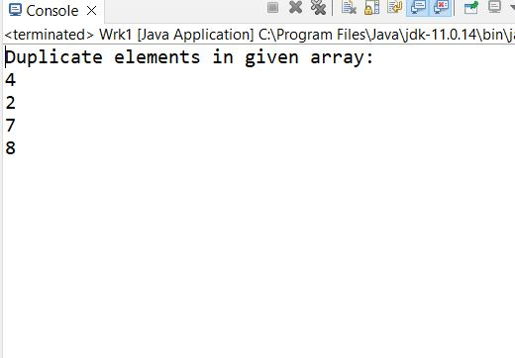

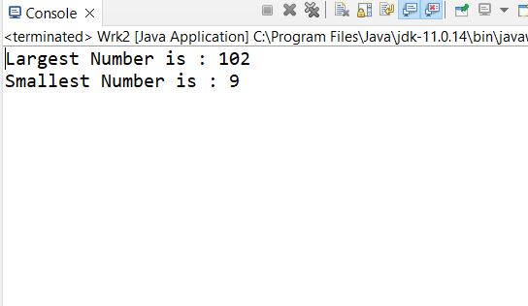

**Learning outcomes (What I have learnt):**

**1.**

**2.**

**3.**